Practical-10
Aim:
Problem 1
A small parking lot has exactly 10 numbered slots (0 to 9). When a vehicle arrives, its
registration number is used to assign it a slot by taking the last digit of the number. If that slot is
already taken, the vehicle moves to the next available slot in order, wrapping around if
necessary. Given a sequence of vehicle registrations, assign each to a slot using this rule and
display the final state of all ten slots.
Describe what your solution does when it encounters an already occupied slot. What happens
when the parking lot is nearly full and many vehicles keep landing on the same slot? Can you
think of a situation where your solution might loop indefinitely?
Problem 2
A library uses a system with 10 shelves numbered 0 to 9. Each book's code is used to decide
which shelf it belongs to by taking the code modulo 10. Unlike the parking lot, each shelf can
hold multiple books stacked together — when two books map to the same shelf, they are simply
added to that shelf's stack. Given a sequence of book codes, place each on the correct shelf
and display the final contents of all shelves.
Describe how your solution handles two books that map to the same shelf. What happens to
search time on a shelf as more and more books pile onto it? Can you think of what would cause
all books to end up on the same shelf?
Practical-link:
https://github.com/kahanipatel156-dev/FDSA-Batch-B/tree/main/Practical-10

Screenshots:
Problem-1:
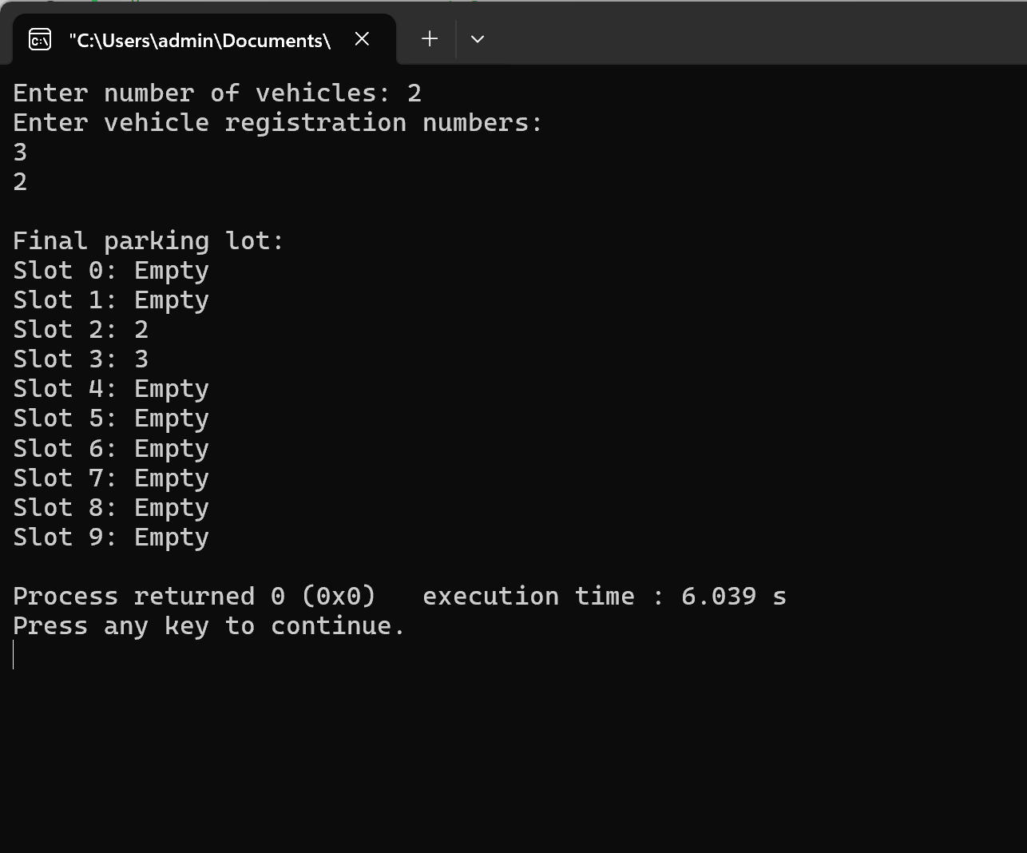
Problem-2:
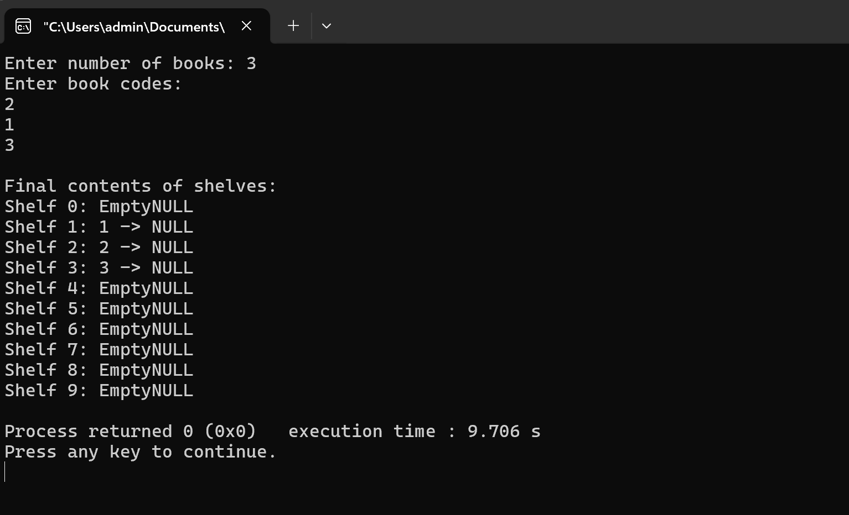
Problem-3:
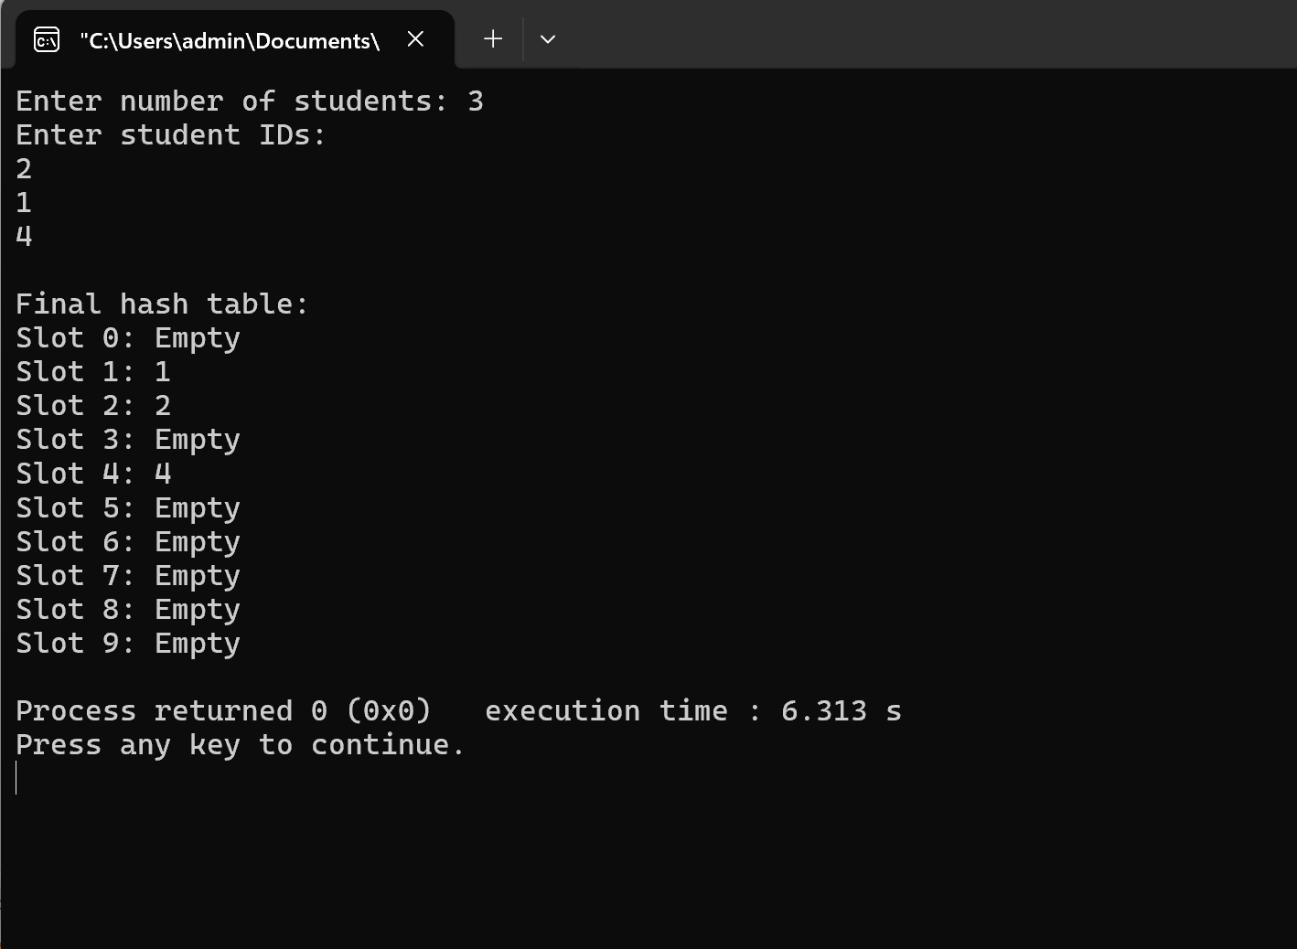
Problem-faced:
Implementation of concepts .
Learning:
Implementation of hash tables.

